TS C002 V3.0.0 (1999-10)
Technical Specification
China Wireless Telecommunication Standard (CWTS);
Working Group 1 (WG1);

Services provided by the Physical Layer



- Contents
5.1 Definitions 5
5.2 Abbreviations 5
6.1 Interface to MAC 7
6.2 Interface to RRC 7
7.1 General 7
7.2 Overview of L1 functions 8
7.3 L1 interactions with L2 retransmission functionality 8
8.1 Uplink models 9
8.2 Downlink models 10
8.3 Relay link Model 12
9.1 General concepts about Transport Channels 12
9.1.1 Transport Block 12
9.1.2 Transport Block Set 12
9.1.3 Transport Block Size 12
9.1.4 Transport Block Set Size 13
9.1.5 Transmission Time Interval 13
9.1.6 Transport Format 13
9.1.7 Transport Format Set 14
9.1.8 Transport Format Combination 14
9.1.9 Transport Format Combination Set 14
9.1.10 Transport Format Indicator (TFI) 15
9.1.11 Transport Format Combination Indicator (TFCI) 15
9.1.12 Rate matching 16
9.2 Types of Transport Channels 16
9.3 Slotted Mode 18
10.1 Uplink 18
10.2 Downlink 19
11.1 Measurements of downlink channels 21
11.1.1 Observed time difference to GSM cell 21
11.1.2 CCPCH RX E_{c}/I₀ 21
11.1.3 CCPCH Rx SIR 21
11.1.4 CCPCH Rx RSCP 21
11.1.5 CCPCH Rx ISCP 22
11.1.6 Cell Signal strength (RSSI) 22
11.1.7 Alternate mode Signal strength 22
11.1.8 Transport CH BLER 22
11.1.9 Physical CH BER 23
11.1.10 Total Tx Power 24
11.1.11 Code Tx Power 24
11.2 Measurements on uplink channels 24
11.2.1 UL load 24
11.2.2 UE Tx Power 24
11.2.3 Transport CH BLER 25
11.2.4 Physical CH BER 25
11.3 Miscellaneous measurements 25
11.3.1 Time of Arrival (TOA) 25
11.3.2 Direction of Arrival (DOA) 25
12.1 Generic names of primitives between layers 1 and 2 27
12.1.1 PHY-Data-REQ 27
12.1.2 PHY- Data-IND 28
12.1.3 PHY-Status-IND 28
12.2 Generic names of primitives between layers 1 and 3 28
12.2.1 STATUS PRIMITIVES 28
12.2.2 CONTROL PRIMITIVES 29
12.3 Parameter definition 31
12.3.1 Error code 31
12.3.2 Event value 31
12.3.3 Physical channel description 31
12.3.4 Transport channel description 31

- Intellectual Property Rights

- Scope
The present document is a technical specification of the services provided by the physical layer of TD-SCDMAto upper layers.

- References
References may be made to:
a) specific versions of publications (identified by date of publication, edition number, version number, etc.), in which case, subsequent revisions to the referenced document do not apply;
b) all versions up to and including the identified version (identified by "up to and including" before the version identity);
c) all versions subsequent to and including the identified version (identified by "onwards" following the version identity); or
d) publications without mention of a specific version, in which case the latest version applies.
A non-specific reference to an ETS shall also be taken to refer to later versions published as an EN with the same number.

- CWTS TS C106: Physical layer; measurements
- 3GPP TS 25.224: TDD; physical layer procedures
- 3GPP TS 25.201: Physical layer –General Description
- CWTS TS C103 : TD-SCDMA multiplexing, channel coding and interleaving description

- Definitions and Abbreviations

Definitions
See [3] for a definition of fundamental concepts and vocabulary.

Abbreviations

ARQ Automatic Repeat Request
BCCH Broadcast Control Channel
BCH Broadcast Channel
- Control-
CC Call Control
CCCH Common Control Channel
CCH Control Channel
CCTrCH Coded Composite Transport Channel
CN Core Network
CRC Cyclic Redundancy Check
DC Dedicated Control (SAP)
DCA Dynamic Channel Allocation
DCCH Dedicated Control Channel
DCH Dedicated Channel
DL Downlink
DRNC Drift Radio Network Controller
DSCH Downlink Shared Channel
DTCH Dedicated Traffic Channel
FACH Forward Link Access Channel
FCS Frame Check Sequence

GC General Control (SAP)
HO Handover
ITU International Telecommunication Union
kbps kilo-bits per second
L1 Layer 1 (physical layer)
L2 Layer 2 (data link layer)
L3 Layer 3 (network layer)
LAC Link Access Control
LAI Location Area Identity
MAC Medium Access Control
MM Mobility Management
Nt Notification (SAP)
OCCCH ODMA Common Control Channel
ODCCH ODMA Dedicated Control Channel
ODCH ODMA Dedicated Channel
ODMA Opportunity Driven Multiple Access
ORACH ODMA Random Access Channel
ODTCH ODMA Dedicated Traffic Channel
PCCH Paging Control Channel
PCH Paging Channel
PDU Protocol Data Unit
PHY Physical layer
PhyCH Physical Channels
RACH Random Access Channel
RLC Radio Link Control
RNC Radio Network Controller
RNS Radio Network Subsystem
RNTI Radio Network Temporary Identity
RRC Radio Resource Control
SAP Service Access Point
SCCH Synchronization Control Channel
SCH Synchronization Channel
SDU Service Data Unit
SRNC Serving Radio Network Controller
SRNS Serving Radio Network Subsystem
TCH Traffic Channel
TDD Time Division Duplex
TFCI Transport Format Combination Indicator
TFI Transport Format Indicator
TMSI Temporary Mobile Subscriber Identity
TPC Transmit Power Control
U- User-
UE User Equipment
UE_{R} User Equipment with ODMA relay operation enabled
UL Uplink
UMTS Universal Mobile Telecommunications System
URA UTRAN Registration Area
UTRA UMTS Terrestrial Radio Access
UTRAN UMTS Terrestrial Radio Access Network

- Interfaces to the physical layer
The physical layer (layer 1) is the lowest layer in the OSI Reference Model and it supports all functions required for the transmission of bit streams on the physical medium.
The physical layer interfaces the Medium Access Control (MAC) Layer and the Radio Resource Control (RRC) Layer as depicted in figure 1.

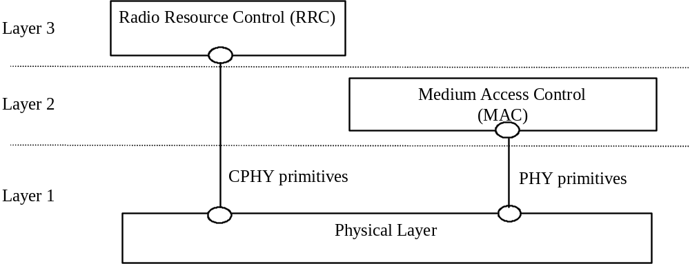

Figure 1 : Interfaces with the Physical Layer

Interface to MAC
The physical layer interfaces the MAC entity of layer 2.. Communication between the Physical Layer and MAC is in an abstract way performed by means of PHY-primitives defined which do not constrain implementations.
NOTE: The terms physical layer and layer 1, will be used synonymously in this description.
The PHY-primitives exchanged between the physical layer and the data link layer provide the following functions:
- transfer of transport blocks over the radio interface
- indicate the status of the layer 1 to layer 2

Interface to RRC
The physical layer interfaces the RRC entity of layer 3 in the UE and in the network.

Communication is performed in an abstract way by means of CPHY-primitives. They do not constrain implementations.

The CPHY-primitives exchanged between the physical layer and the Network layer provide the following function:

- control of the configuration of the physical layer

The currently identified exchange of information across that interface have only a local significance to the UE or Network.
- Services and functions of the physical layer

General
The physical layer offers data transport services to higher layers. The access to these services is through the use of transport channels via the MAC sub-layer. The characteristics of a transport channel are defined by its transport format (or format set), specifying the physical layer processing to be applied to the transport channel in question, such as inner channel coding and interleaving, and any service-specific rate matching as needed.

The physical layer operates exactly according to the L1 radio frame timing. A transport block is defined as the data accepted by the physical layer to be jointly encoded. The transmission block timing is then tied exactly to this L1 frame timing, e.g. every transmission block is generated precisely every 10ms, or a multiple of 10 ms.

A UE can set up multiple transport channels simultaneously, each having own transport characteristics (e.g. offering different error correction capability). Each transport channel can be used for information stream transfer of one radio bearer or for layer 2 and higher layer signalling messages.

The multiplexing of these transport channels onto the same or different physical channels is carried out by L1. In addition, the Transport Format Combination Indication field (TFCI) shall uniquely identify the transport format used by each transport channel of the Coded Composite Transport Channel within the current radio frame.

Overview of L1 functions
The physical layer performs the following main functions:
- FEC encoding/decoding of transport channels
- Measurements and indication to higher layers (e.g. FER, SIR, timing advance, DOA, transmission power, etc...)
- Macrodiversity distribution/combining and handover execution
- Error detection on transport channels
- Multiplexing of transport channels and demultiplexing of coded composite transport channels
- Rate matching
- Mapping of coded composite transport channels on physical channels
- Modulation and spreading/demodulation and despreading of physical channels
- Frequency and time (chip, bit, slot, frame) synchronization
- Closed-loop power control
- Power weighting and combining of physical channels
- RF processing
- Beamforming
- UE position detection

L1 interactions with L2 retransmission functionality
Provided that the RLC PDUs are mapped one-to-one onto the Transport Blocks, Error indication may be provided by L1 to L2. For that purpose, the L1 CRC can be used for individual error indication of each RLC PDU. The L1 CRC will then serve multiple purposes:
- Error indication for uplink macro diversity selection combining (L1)
- Frame error indication for speech services
- Quality indication
- Error indication for L2 retransmissions

As a conclusion, L1 needs to give an error indication to L2 for each erroneous Transport Block delivered.
- Model of physical layer of the UE

Uplink models
Figure 2 shows models of the UE’s physical layer in the uplink for TD-SCDMA. It shows two models: DCH model and RACH model. Some restriction exist for the use of different types of transport channel at the same time, these restrictions are described in the chapter “UE Simultaneous Physical Channel combinations”.

Editors note: Models for uplink transport channels currently marked ffs will be necessary if these channels are included in the description.
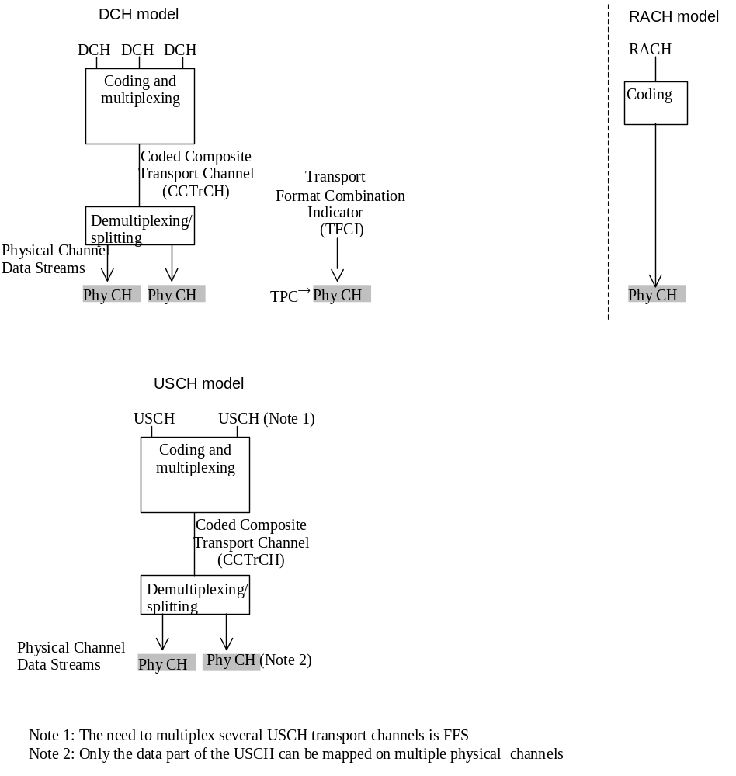
Figure 2: Model of the UE’s physical layer – uplink
The DCH model shows that one or several DCHs can be processed and multiplexed together by the same coding and multiplexing unit. The detailed functions of the coding and multiplexing unit are not defined in this document but in [4]. The single output data stream from the coding and multiplexing unit is denoted Coded Composite Transport Channel (CCTrCH).

The bits on a CCTrCH Data Stream can be mapped on the same Physical Channel and should have the same C/I requirement.

On the downlink, multiple CCTrCH can be used simultaneously with one UE. In TD-SCDMA, different power control loops can be applied for different CCTrCH. One physical channel can only have bits coming from the same CCTrCH.

On the uplink, multiple CCTrCH can be used simultaneously.

When multiple CCTrCH are used by one UE, one or several TFCI can be used, but each CCTrCH has only zero or one corresponding TFCI. these different TFCI can be mapped on different DPCH.

The data stream of the CCTrCH is fed to a data demultiplexing/splitting unit that demultiplexes/splits the CCTrCH’s data stream onto one or several Physical Channel Data Streams.

The current configuration of the coding and multiplexing unit is either signalled to, or optionally blindly detected by, the network for each 10 ms frame. If the configuration is signalled, it is represented by the Transport Format Combination Indicator (TFCI) bits. Note that the TFCI signalling only consists of pointing out the current transport format combination within the already configured transport format combination set. In the uplink there is only one TFCI representing the current transport formats on all DCHs of one CCTrCH simultaneously.

The model for the RACH case shows that RACH is a common type transport channel in the uplink. RACHs are always mapped one-to-one onto physical channels, i.e. there is no physical layer multiplexing of RACH. Service multiplexing is handled by the MAC layer. The CPCH which is another common type transport channel has a physical layer model as shown in the above figure.

Downlink models
Figure 3 shows the model of the UE’s physical layer for the downlink,. Note that there is a different model for each transport channel type.

Editors note: Models for downlink transport channels currently marked ffs will be necessary if these channels are included in the description.

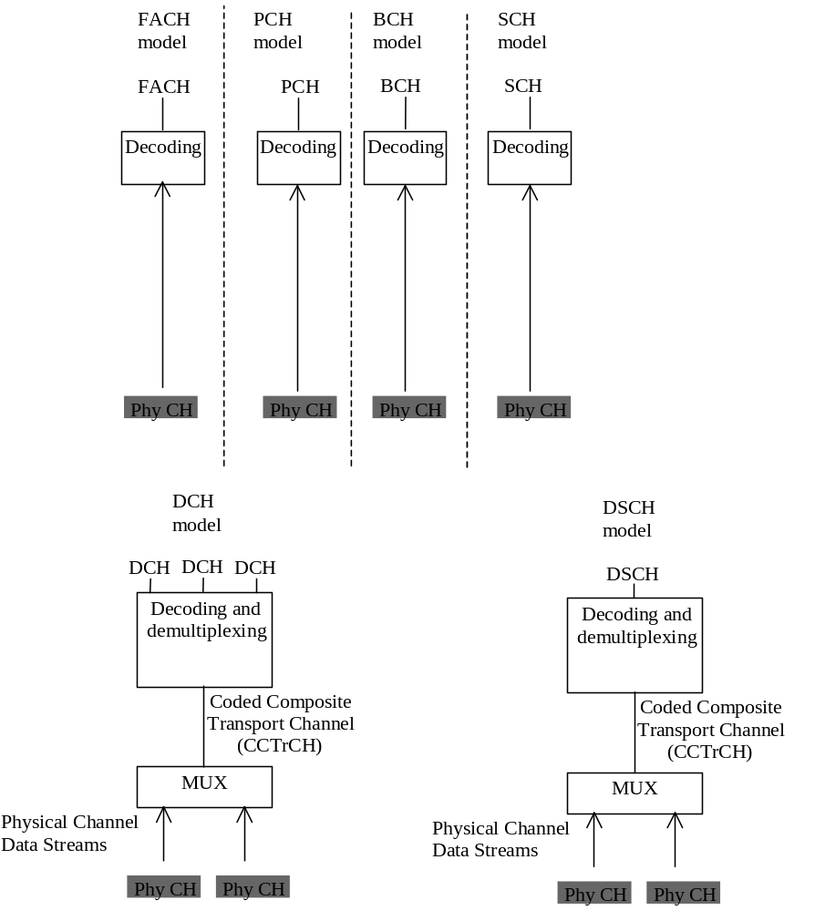
Figure 3: Model of the UE’s physical layer – downlink

For the DCH case, the mapping between DCHs and physical channel data streams works in the same way as for the uplink. Note however, that the number of DCHs, the coding and multiplexing etc. may be different in uplink and downlink.

The physical channels carrying the same physical channel data stream are combined in the UE receiver, excluding the pilot, and in some cases the TPC bits. TPC bits received on certain physical channels may be combined provided that RAN has informed the UE that the TPC information on these channels is identical.

The downlink models for the BCH, PCH and FACH show that BCH, PCH and FACH are always mapped one-to-one onto physical channels, i.e. there is no physical layer multiplexing of BCH, PCH and FACH. Service multiplexing is handled by the MAC layer.

Relay link Model

Figure 4 illustrates the relay link model of the UE’s physical layer

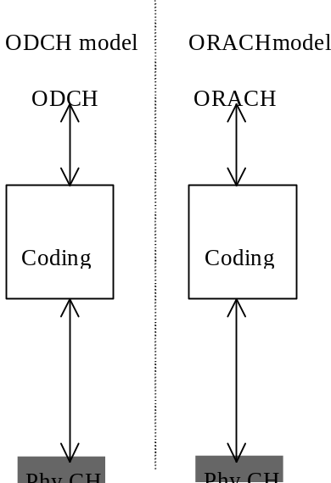
Figure4 : Model of the UE’s physical layer - relay link

The ORACH is a channel used within UE’s to transmit and receive probing messages, and also to transmit and receive small packets of information. The ODCH is used to transmit larger amounts of data over a number of hops between UE’s.

- Formats and configurations for L1 data transfer

General concepts about Transport Channels
Layer 2 is responsible for the mapping of data onto L1 via the L1/L2 interface that is formed by the transport channels. In order to describe how the mapping is performed and how it is controlled, some definitions and terms are required. The required definitions are given in the following sections. Note that the definitions are generic for all transport channel types, i.e. not only for DCHs.

All Transport Channels are defined as unidirectional (i.e. uplink, downlink, or relay-link). This means that a UE can have simultaneously (depending on the services and the state of the UE) one or several transport channels in the downlink, and one or more Transport Channel in the uplink.

Transport Block
This is the basic unit exchanged between L1 and MAC, for L1 processing.

A Transport Block typically corresponds to an RLC PDU or corresponding unit.it could also be formed by a MAC peer-to-peer message. Layer 1 adds a CRC for each Transport Block.

Transport Block Set
This is defined as a set of Transport Blocks which are exchanged between L1 and MAC at the same time instance using the same transport channel.

Transport Block Size
This is defined as the number of bits in a Transport Block.

Transport Block Set Size
This is defined as the number of bits in a Transport Block Set.

Transmission Time Interval
This is defined as the inter-arrival time of Transport Block Sets, and is equal to the periodicity at which a Transport Block Set is transferred by the physical layer on the radio interface. It is always a multiple of the minimum interleaving period (e.g. 10ms, the length of one Radio Frame). The MAC delivers one Transport Block Set to the physical layer every TTI.

Figure5 shows an example where Transport Block Sets, at certain time instances, are exchanged between MAC and L1 via three parallel transport channels. Each Transport Block Set consists of a number of Transport Blocks. The Transmission Time Interval, i.e. the time between consecutive deliveries of data between MAC and L1, is also illustrated. Last, the case when the last Transport Block is smaller than the allowed size is shown, with the topmost Transport Block being partially empty.
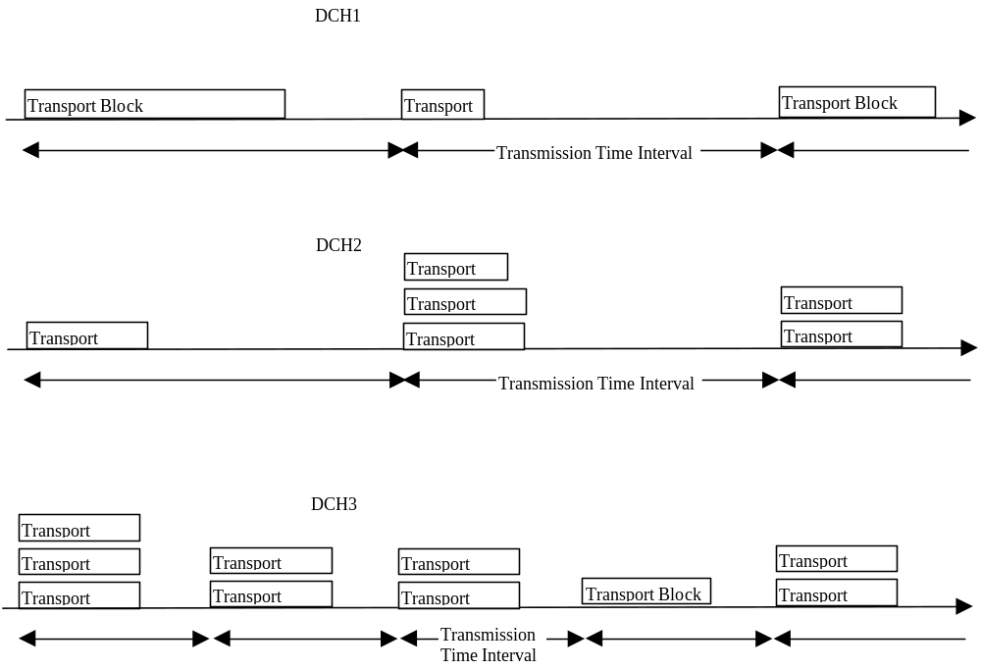
Figure5. Exchange of data between MAC and L1

Transport Format
Note: The section 7.1.6 needs to FFS in TD-SCDMA. In the following the section 7.1.7 –7.1.11 are similar.
This is defined as a format offered by L1 to MAC (and vice versa) for the delivery of a Transport Block Set during a Transmission Time Interval on a Transport Channel. The Transport Format constitutes of two parts – one dynamic part and one semi-static part.

Attributes of the dynamic part are:
- Transport Block Size
- Transport Block Set Size
- Transmission Time Interval

Attributes of the semi-static part are:
- Transmission Time Interval
- Error protection scheme to apply
- Type of error protection e.g. Turbo Code, Convolutionnal Code
- convolutional code ratio
- Resulting code ratio after static rate matching
- Size of CRC

In the following example, the Transmission time Interval is seen as a semi-static part
Example:
- Dynamic part: {320 bits, 640 bits}, Semi-static part: {10ms, Inner coding only, repeat 1/12 of the bits}

Transport Format Set
This is defined as the set of Transport Formats associated to a Transport Channel.

The semi-static parts of all Transport Formats are the same within a Transport Format Set.

Effectively the first two attributes of the dynamic part form the instantaneous bit rate on the Transport Channel. Variable bit rate on a Transport Channel may, depending on the type of service which is mapped onto the transport channel, be achieved by changing between each Transmission Time Interval one of the following:
- the Transport Block Size only
- the Transport Block Set Size only
- both the Transport Block Size and the Transport Block Set Size

Example 1:
- Dynamic part: {20 bits, 20 bits}; {40 bits, 40 bits}; {80 bits, 80 bits}; {160 bits, 160 bits}
- Semi-static part: {10ms, Inner coding only, repeat 1/12 of the bits}

Example 2:
- Dynamic part: {320 bits, 320 bits}; {320 bits, 640 bits}; {320 bits, 1280 bits}
- Semi-static part: {10ms, Inner coding only, repeat 1/12 of the bits}

The first example may correspond to a Transport Channel carrying a speech service, requiring blocks delivered on a constant time basis. In the second example, which illustrates the situation where a non-real time service is carried by the Transport Channel, the number of blocks delivered per Transmission Time Interval varies between the different Transport Formats within the Transport Format Set. Referring to Figure, the Transport Block Size is varied on DCH1 whereas the Transport Block Set Size is fix. That is, a Transport Format Set where the dynamic part has a variable Transport Block Size has been assigned for DCH1. On DCH2 and DCH3 it is instead the Transport Block Set Sizes that are varied. That is, the dynamic parts of the corresponding Transport Format Sets include variable Transport Block Set Sizes.

Transport Format Combination
The layer 1 multiplexes one or several Transport Channels, and for each Transport Channel, there exists a list of transport formats (Transport Format Set) which are applicable. Nevertheless, at a given point of time, not all combinations may be submitted to layer 1 but only a subset, the Transport Format Combination. This is defined as an authorised combination of the combination of currently valid Transport Formats that can be submitted simultaneously to the layer 1 for transmission on a Coded Composite Transport Channel of a UE, i.e. containing one Transport Format from each Transport Channel.

Example:

DCH1: Dynamic part: {20 bits, 20 bits}, Semi-static part: {10ms, Inner coding only, repeat 1/12 of the bits}
DCH2: Dynamic part: {320 bits, 1280 bits}, Semi-static part: {10ms, Inner coding only, puncture 1/14 of the bits}
DCH3: Dynamic part: {320 bits, 320 bits}, Semi-static part: {40ms, Outer coding, repeat 1/20 of the bits}

Transport Format Combination Set
This is defined as a set of Transport Format Combinations on a Coded Composite Transport Channel.

Example:

Dynamic part:

Combination 1: DCH1: {20 bits, 20 bits}, DCH2: {320 bits, 1280 bits}, DCH3: {320 bits, 320 bits}
Combination 2: DCH1: {40 bits, 40 bits}, DCH2: {320 bits, 1280 bits}, DCH3: {320 bits, 320 bits}
Combination 3: DCH1: {160 bits, 160 bits}, DCH2: {320 bits, 320 bits}, DCH3: {320 bits, 320 bits}

Semi-static part:

DCH1: {10ms, Inner coding only, repeat 1/12 of the bits}
DCH2: {10ms, Inner coding only, puncture 1/14 of the bits}
DCH3: {40ms, Outer coding, repeat 1/20 of thebits}

The Transport Format Combination Set is what is given to MAC for control. However, the assignment of the Transport Format Combination Set is done by L3. When mapping data onto L1, MAC chooses between the different Transport Format Combinations given in the Transport Format Combination Set. Since it is only the dynamic part that differ between the Transport format Combinations, it is in fact only the dynamic part that MAC has any control over.

The semi-static part, together with the target value for the L1 closed loop power control, correspond to the service attributes:
- Quality (e.g. BER)
- Transfer delay

These service attributes are then offered by L1. However, it is L3 that guarantees that the L1 services are fulfilled since it is in charge of controlling the L1 configuration, i.e. the setting of the semi-static part of the Transport Formats. Furthermore, L3 controls the target for the L1 closed loop power control.

Note that a Transport Format Combination Set need not contain all possible Transport Format Combinations that can be formed by Transport Format Sets of the corresponding Transport Channels. It is only the allowed combinations that are included. Thereby a maximum total bit rate of all transport channels of a Code Composite Transport Channel can be set appropriately. That can be achieved by only allowing Transport Format Combinations for which the included Transport Formats (one for each Transport Channel) do not correspond to high bit rates simultaneously.

The selection of Transport Format Combinations can be seen as a fast part of the radio resource control. The dedication of these fast parts of the radio resource control to MAC, close to L1, means that the flexible variable rate scheme provided by L1 can be fully utilised. These parts of the radio resource control should be distinguished from the slower parts, which are handled by L3. Thereby the bit rate can be changed very fast, without any need for L3 signalling.

Transport Format Indicator (TFI)
The TFI is a label for a specific transport format within a transport format set. It is used in the inter-layer communication between MAC and L1 each time a transport block set is exchanged between the two layers on a transport channel.

Transport Format Combination Indicator (TFCI)
This is a representation of the current Transport Format Combination.

There is a one-to-one correspondence between a certain value of the TFCI and a certain Transport Format Combination. The TFCI is used in order to inform the receiving side of the currently valid Transport Format Combination, and hence how to decode, de-multiplex and deliver the received data on the appropriate Transport Channels.

MAC indicates the TFI to Layer 1 at each delivery of Transport Block Sets on each Transport Channel. Layer 1 then builds the TFCI from the TFIs of all parallel transport channels of the UE , processes the Transport Blocks appropriately and appends the TFCI to the physical control signalling . Through the detection of the TFCI the receiving side is able to identify the Transport Format Combination.. Nevertheless, from the assigned Transport Format Combinations, the receiving side has all information it needs in order to decode the information and transfer it to MAC on the appropriate Transport Channels.

The multiplexing and exact rate matching patterns follow predefined rules and may therefore be derived (given the Transport Format Combinations) by transmitter and receiver without signalling or by very fast signalling (this procedure may loss some real time data)over the radio interface.

When the meaning of the TFCI field needs to be reconfigured, two procedures can be used depending on the level of reconfiguration:
- Complete reconfiguration of TFCI: In this procedure all TFCI values are reinitialized and new values are defined instead. The complete reconfiguration requires an explicit synchronization between the UE and RAN regarding when the reconfiguration becomes valid.
- Incremental reconfiguration of TFCI: In this procedures, a part of the TFCI values before and after the reconfiguration remain identical (note that this must be true for at least a TFCI that carry the signaling connection). This procedure supports addition, removal or redefinition of TFCI values. This procedure does not require an explicit execution time. This procedure may imply the loss of some user-plane data.

Rate matching
Two levels of rate matching are defined on the radio interface:
- A static rate matching per Transport Channel. The static rate matching is part of the semi-static attributes of the Transport Channel
- A dynamic rate matching per CCTrCH. The dynamic rate matching adjusts the size of the physical layer data payload to the physical channel as requested by RRC.
The static rate matching and the dynamic rate matching to be applied by the physical layer are indicated by RRC to the physical layer.
RRC is responsible for configurating the physical layer on whether:
- Blind Rate Detection or TFCI is used
- Dynamic rate matching is applied or not on the downlink

Types of Transport Channels
A general classification of transport channels is into two groups:
- common channels and
- dedicated channels (where the UEs can be unambiguously identified by the physical channel, i.e. code and frequency)
Common transport channel types are:
- Random Access Channel(s) (RACH) characterized by:
- existence in uplink only,
- limited data field.
- collision risk,
- open loop power control,
- ODMA Random Access Channel(s) (ORACH) characterized by:
- existence in relay-link
- collision risk,
- open loop power control,
- no timing advance control
- Forward Access Channel(s) (FACH) characterized by:
- existence in downlink only,
- possibility use beam forming,
- use fast power control,
- possibility to change rate fast (each 5ms),

- Broadcast Channel (BCH) characterized by:
- existence in downlink only,
- low fixed bit rate and
- requirement to be broadcast in the entire coverage area of the cell.
- Paging Channel (PCH) characterized by:
- existence in downlink only,
- association with a physical layer signal, the Page Indicator, to support efficient sleep mode procedures and
- requirement to be broadcast in the entire coverage area of the cell.
- Synchronisation channel (SCH) characterised by :
- existence in uplink and downlink
- low fixed bit rate
- requirement to be broadcast in the entire coverage area of the cell
- Downlink Shared Channel(s) (DSCH) characterised by:
- existence in downlink only,
- possibility to use beamforming,
- possibility to use slow power control,
- possibility to use fast power control, when associated with dedicated channel(s)
- possibility to be broadcast in the entire cell
- always associated with another channel (DCH or DSCH Control Channel).
- DSCH Control Channel characterised by:
- existence in downlink only,
- possibility to use beam forming,
- possibility to use slow power control,
- lack of fast power control
Editor’ s note: It is for further study whether or not the DSCH Control Channel needs to be regarded as separate transport channel type from FACH. Seen from the upper layers, the current requirements are identical to a FACH, but some extra L1 information (e.g.TPC bits) may lead to a different physical channel.

- Uplink Shared channel (USCH) characterised by:
- existence in uplink only,
- possibility to use beam forming,
- possibility to use power control,
- possibility to change rate fast

Dedicated transport channel types are:
- Dedicated Channel (DCH) characterized by:
- existing in uplink or downlink
- possibility to use beam forming,
- possibility to change rate fast (each 5ms),
- fast power control and

3. ODMA Dedicated Channel (ODCH) characterized by:
- possibility to use beam forming,
- possibility to change rate fast (each 5ms),
- closed loop power control,
- closed loop timing advance control,
To each transport channel, there is an associated Transport Format (for transport channels with a fixed or slow changing rate) or an associated Transport Format Set (for transport channels with fast changing rate).

Slotted Mode
Slotted Mode is defined as the mechanism whereby certain idle periods are created in downlink radio frames so that the UE can perform measurement reports during these periods (more details can be found in [4]). Applicability to uplink is FFS.

Slotted Mode is obtained by layer 2 using transport channels provided by the layer 1 as follows :
- Slotted Mode is controlled by the RRC layer which configures the layer 2 and the physical layer
- The number of occurrences of slotted frames is controlled by RRC, and can be modified by RRC signalling
- Layer 2 instructs every Transmission Time Interval the Layer 1 on whether slotted mode should be applied for a given Transport Format Combination Set. The instruction may indicate also the type of slotted mode (beginning, middle or end of the frame).
- The slotting can be either cyclic (typically for circuit services) or a-periodic (typically for NRT services)
- It is under the responsibility of the layer 2 if necessary to either buffer some layer 2 PDUs (typically at the RLC layer for NRT services) or to rate adapt the data flow (similarly to GSM) so that there is no loss of data because of slotted mode. This will be service dependant and controlled by the RRC layer.
- UE Simultaneous Physical Channels combinations
This sections describes the requirements from the UE to send and receive on multiple Transport Channels which are mapped on different physical channels simultaneously depending on the service capabilities and requirements. The section will describe the impacts on the support for multiple services (e.g. speech call and SMS-CB) depending on the UE capabilities.

Uplink
The table describes the possible combinations of physical channels that can be supported in the uplink by one UE at any one time.
 | Physical Channel Combination | Transport Channel Combination | Baseline Capability or Service dependent | Comment
1 | PRACH | RACH | Baseline | The PRACH physical channel includes the preambles and the message.
2 | CCPCH consisting of one control and one data part during the message portion | USCH | Service dependent | The CCPCH physical channel includes the preambles and the message.  The maximum channel bit rate is dependant on UE Service Capability
3 | CCPCH consisting of one control and more than one data part during the message portion | USCH | Service dependent | The PCPCH physical channel includes the preambles and the message.  The maximum channel bit rate is dependant on UE Service Capability
4 | DPCH consisting of one DPCCH and one DPDCH | One or more DCH coded into a single CCTrCH | Service dependent | The maximum number of DCHs and the maximum channel bit rate are dependant on UE Service Capability
5 | DPCH consisting of one DPCCH and more than one DPDCH | One or more DCH coded into a single CCTrCH | Service dependent | The maximum number of DCHs and the maximum channel bit rate are dependant on UE Service Capability

Downlink
The table describes the possible combinations of physical channels that can be supported in the downlink by one UE at any one time.
 | Physical Channel Combination | Transport Channel Combination | Baseline Capability or Service dependent | Comment
1 | CCPCH | BCH | Baseline
2 | CCPCH | FACH + PCH | Baseline | The maximum channel bit rate that can be supported is dependent on the UE Service Capability
4 | More than one CCPCH | More than one FACH + PCH | Service dependent
5 | CCPCH + DPCH | One or more DCH coded into a single CCTrCH | Service dependant | The maximum number of DCHs and the maximum channel bit rate are dependent on UE Service Capability
6 | CCPCH + more than one DPCH | One or more DCH coded into a single CCTrCH | Service dependent | The maximum number of DCHs and the maximum channel bit rate are dependent on UE Service Capability
7 | CCPCH + one or more DPCH | DSCH + one or more DCH coded into a single CCTrCH | Service dependent | The maximum number of DCHs and the maximum channel bit rate are dependent on UE Service Capability
8 | CCPCH + one or more DPCH | FACH + one or more DCH coded into a single CCTrCH | Service dependent | The maximum number of DCHs and the maximum channel bit rate are dependent on UE Service Capability  This combination of physical channels is used for DRAC control of an uplink DCH and for receiving services such as cell broadcast or multicast whilst in connected mode.
9 | CCPCH + one or more DPCH | FACH + DSCH + one or more DCH coded into a single CCTrCH | Service dependent | The maximum number of DCHs and the maximum channel bit rate are dependent on UE Service Capability  This combination of physical channels is used for simultaneous DSCH and DRAC control of an uplink DCH.
10 | More than one CCPCH + more than one DPDCH | More than one DCH coded into one or more CCTrCH | Service dependent | See note 2

- Measurements provided by the physical layer

One of the key services provided by the physical layer is the measurement of various quantities which are used to trigger or perform a multitude of functions. Both the UE and the RAN are required to perform a variety of measurements. The standard will not specify the method to perform these measurements or stipulate that the list of measurements provided in this section must all be performed. While some of the measurements are critical to the functioning of the network and are mandatory for delivering the basic functionality (e.g., handover measurements, power control measurements), others may be used by the network operators in optimising the network (e.g., radio environment).
Measurements may be made periodically and reported to the upper layers or may be event-triggered (e.g., CCPCH becomes better than the previous best CCPCH. The measurements are tightly coupled with the service primitives in that the primitives’ parameters may constitute some of the measurements.
The list and frequency of measurements which the physical layer reports to higher layers is described in this section.
The measurement quantities measured by the physical layer shall be such that the following principles are applied:
For handover measurements, the decoding of parameters on the BCCH logical channel of monitored neighbouring cells, should not, in general, be needed for calculating the measurement result. If there is a need to adjust the measurement result with parameters broadcast on the CCPCH, these parameters shall be provided by the RAN in inband measurement control messages. There may be some exceptions to this rule.
In idle mode or in RRC connected mode using common Transport Channels, the UE shall be able to monitor cells for cell reselection, without being required to frequently decode parameters on the BCCH logical channel of the monitored neighbouring cells. The decoding frequency of these parameters, set by the cell reselection algorithm, should be such that UE standby times are not significantly decreased.

Measurements of downlink channels

Observed time difference to GSM cell
This measure is mandatory for the UE if the handover to GSM service is to be supported.
Measurement | Measured time difference to GSM cell
Source | L1 (UE)
Destination | RRC (RNC) for maintenance and handover to GSM
Reporting Trigger | On-demand, Event-triggered
Definition | Time difference between the CCPCH of the current cell and the timing of the GSMcell.
Precision Requirement | For handover, precision to [x] microseconds

CCPCH RX E_{c}/I₀
This measure is mandatory for the UE.
Measurement | CCPCH Rx Ec/Io
Source | L1(UE)
Destination | RRC (UE, RNC),
Reporting Trigger | Periodic or on demand and event triggered
Definition | –20log₁₀(E_{c}/I_{o}) where E_{c} is the energy per chip of the CCPCH measured in the searcher and I_{o} is the received spectral density.
Precision Requirement | 1 dB

CCPCH Rx SIR
This measure is mandatory for the UE.
Measurement | Primary CCPCH Rx SIR
Source | L1 (UE)
Destination | RRC (UE, RNC)
Reporting Trigger | periodic or event triggered
Definition | This quantity is a ratio of the Primary CCPCH Received Signal Code Power (RSCP) to the Interference Signal Code Power (ISCP). The RSCP is the measured symbol power of the CCPCH at the demodulator output and the ISCP is the measured interference symbol power.
Precision Requirement | 1 dB

CCPCH Rx RSCP
This measure is mandatory for the UE.
Measurement | CCPCH Rx RSCP
Source | L1(UE)
Destination | RRC (UE, RNC)
Reporting Trigger | periodic or event triggered
Definition | Received Signal Code Power, is received power on one code after despreading, defined on the pilot symbols.
Precision Requirement | 1 dB

CCPCH Rx ISCP
This measure is mandatory for the UE.
Measurement | Primary CCPCH Rx ISCP
Source | L1(UE)
Destination | RRC (UE, RNC)
Reporting Trigger | periodic or event triggered
Definition | Interference on Signal Code Power, is the interference on the mentioned received signal after despreading. Thereby only the non-orthogonal part of the interference is included.
Precision Requirement | 1 dB

Cell Signal strength (RSSI)
This measure is mandatory for the UE.
Measurement | signal strength
Source | L1(UE)
Destination | RRC (RNC),
Reporting Trigger | Periodic, event triggered, on demand
Definition | Received Signal Strength Indicator, the wideband received power within the channel bandwidth averaged over [1 s] interval.
Precision Requirement | 1 dB

Alternate mode Signal strength

GSM Signal Strength
This measure is mandatory for the UE if the service handover to GSM is to be supported.
Measurement | GSM signal strength
Source | L1(UE)
Destination | RRC (RNC)
Reporting Trigger | Periodic, event triggered, on demand
Definition | reference GSM document 05.08
Precision Requirement | reference GSM document 05.08

Transport CH BLER
This measure is mandatory for the UE.
Measurement | transport channel BLER (BLock Error Rate)
Source | L1(UE)
Destination | RRC(RNC,UE)
Reporting Trigger | periodic
Definition | The error detection mechanism will determine whether or not a block error occurred.
Precision Requirement | Transport channel dependent

Physical CH BER
This measure is mandatory for the UE.
Measurement | physical channel BER
Source | L1(UE)
Destination | RRC(UE,RNC)
Reporting Trigger | On-demand, Event-triggered
Definition | The estimate of the raw BER of the physical channel calculated only on the data part.
Precision Requirement | [10%]

Total Tx Power
Measurement | total Tx power
Source | L1(Node-B)
Destination | RRC(RNC)
Reporting Trigger | On-demand, periodic, Event-triggered
Definition | The total power emitted by the Node-B within the channel bandwidth averaged over an interval of [1 s]
Precision Requirement | 1 dB

Code Tx Power
Measurement | Code Tx power
Source | L1(Node-B)
Destination | RRC (RNC)
Reporting Trigger | On-demand, periodic, Event-triggered
Definition | The total power emitted by the Node-B on one channelisation code for one UE averaged over [100 ms]
Precision Requirement | 1 dB

Measurements on uplink channels

UL load
Measurement | UL load
Source | L1 (Node B)
Destination | RRC(RNC)
Reporting Trigger | On-demand, Event-triggered, Periodic
Definition | the total received signal power for a carrier within the cell
Precision Requirement | 1 dB

UE Tx Power
This measure is mandatory for the UE.
Measurement | UE Tx power
Source | L1(UE)
Destination | RRC (UE,RNC)
Reporting Trigger | On-demand, periodic, Event-triggered
Definition | RRC (UE) – the total Tx power, measured at the antenna connector, averaged over [100 ms]  RRC (RNC) – indication of Tx power reaching threshold (for example, upper or lower power limits)
Precision Requirement | 3 dB

Transport CH BLER
Measurement | transport channel BLER (BLock Error Rate)
Source | L1(Node-B)
Destination | RRC(RNC)
Reporting Trigger | periodic, event triggered, on demand
Definition | The error detection mechanism will determine whether or not a block error occurred.
Precision Requirement | Transport channel dependent

Physical CH BER
Measurement | physical channel BER
Source | L1(Node-B)
Destination | RRC(RNC)
Reporting Trigger | On-demand, Event-triggered, periodic
Definition | The estimate of the raw BER of the physical channel calculated only on the data part.
Precision Requirement | [10%]

Miscellaneous measurements

Time of Arrival (TOA)
The Time of Arrival (TOA) measurement at a single node-B and/or UE may provide an estimate of the round trip time of signals between the Node-B and the UE and this may be used to calculate a radial distance to the UE within the sector. A group of simultaneous
Measurement | Time of arrival (TOA)
Source | L1(Node-B or UE)
Destination | RRC (RNC-LCS)
Reporting Trigger | on demand, event triggered
Definition | the time of arrival of the uplink transmissions..
Precision Requirement | [ 0,2 ] chip

Direction of Arrival (DOA)
The Direction of Arrival (DOA) measurement at a single node-B may provide an estimate of the direction of each UE worked in this cell. From the measurements of DOA and TOA ,the node-B can get the UE’s positioning .
Measurement | Directin of arrival (DOA)
Source | L1(Node-B)
Destination | RRC (RNC-LCS)
Reporting Trigger | on demand, event triggered
Definition | the direction of arrival of the uplink transmissions
Precision Requirement | 15⁰

- Primitives of the physical layer
The Physical layer interacts with other entities as illustrated in figure 2.1. The interactions with the MAC layer and the RRC layer are shown in terms of primitives where the primitives represent the logical exchange of information and control between the physical layer and higher layers. They do not specify or constrain implementations.
The (adjacent) layers connect to each other through Service Access Points (SAPs). Primitives, therefore, are the conveyer of the information exchange and control through SAPs.
Three types of primitives are used for this document, as follows.

REQUEST
This type is used when a higher layer is requesting a service from a lower layer.
- INIDCATION:
This type is used by a lower layer providing a service to notify its higher layer of activities concerning that higher layer.
- CONFIRM:
This type is used by a lower layer providing the requested service to confirm to the higher layer that the activity has been completed.
The primitives defined below are for local communications between MAC and L1, as well as RRC and L1 in the same protocol stack.
For the physical layer two sets of primitives are defined:
* Primitives between layer 1 and 2:
PHY - Generic name - Type: Parameters.
* Primitives between layer 1 and the RRC entity:
CPHY - Generic name - Type: Parameters.
EDITOR‘S NOTE : This is a logical description of the primitives and does not cover addressing aspects (e.g. Transport Channel ID, Physical Channel ID, start frame number or disconnect frame number).

Generic names of primitives between layers 1 and 2
The primitives between layer 1 and layer 2 are shown in the Table 1.

Table 1. Primitives between layer 1 and 2

Generic Name | Parameters
PHY-DATA-REQ | TFI, compressed mode type, TBS
PHY-DATA-IND | TFI, compressed mode type, TBS, CRC result
PHY-STATUS-IND | Event value

PHY-Data-REQ
The PHY-DATA primitives are used to request SDUs used for communications passed to and from the physical layer. One PHY-DATA primitive is submitted every Transmission Time Interval for each Transport Channel.
Primitive Type: request.

Parameters:
- TFI
- Type of compressed mode (e.g. uncompressed, compressed with beginning/middle/end of frame)
- Transport Block Set
- FN_{CELL}
- Page indicators (PIs) ( PCH only)

PHY- Data-IND
The PHY-DATA primitives are used to indicate SDUs used for Layer 2 passed to and from the physical layer. One PHY-DATA primitive is submitted every Transmission Time Interval for each Transport Channel.
Primitive Type: indicate

Parameters:
- TFI
- Type of compressed mode (e.g. uncompressed, compressed with beginning/middle/end of frame)
- Transport Block Set
- CRC check result

PHY-Status-IND
The PHY-STATUS primitive can be used by the layer 1 to notify higher layers of an event which has occurred.
Primitive Type: indication

Parameters
- Event value

Generic names of primitives between layers 1 and 3
The status primitives between layer 1 and 3 are shown in the Table 2.
Table 2: Status primitives between layer 1 and 3

Generic Name | Parameters
CPHY-Sync-IND | none
CPHY-Out-of-Sync-IND | none
CPHY-Measurement-REQ | Measurement parameters
CPHY-Measurement-IND | Measurement parameters
CPHY-ERROR-IND | Error Code

STATUS PRIMITIVES

CPHY-Sync-IND
This primitive is used for L1 to indicate to RRC that synchronisation of a certain physical channel has been done in the receiver.

Primitive Type: indication

Parameters:
- none

CPHY-Out-of-Sync-IND
Primitive sent from L1 to RRC indicating that synchronisation of a previously configured connection has been lost in the receiver.

Primitive Type: indication

Parameters:
- none

CPHY-Measurement-REQ
The Request primitive is used for RRC to configure L1 measurements.

Primitive Type: request

Parameters:
- transmission power threshold
- Refer to section 9 for measurement parameters

CPHY-Measurement-IND
The Indication primitive is used to report the measurement results

Primitive Type: indication

Parameters:
- Refer to Section 9 for measurement parameters

CPHY-ERROR-IND
The CPHY-ERROR primitive is used to indicate to the management entity that an error has occurred as a result of a physical layer fault.
Primitive Type: indication

Parameters
- Error Code

CONTROL PRIMITIVES
The control primitives between layer 1 and 3 are shown in the Table 3
Table 3. Control primitives between layer 1 and 3

Generic Name | Parameters
CPHY-TrCH-Config-REQ | Transport channel description,
CPHY-TrCH-Config-CNF
CPHY-TrCH_Release-REQ
CPHY-TrCH_Release-CNF
CPHY-RL-Setup-REQ | Physical channel description
CPHY-RL-Setup-CNF | none
CPHY-RL-Release-REQ | none
CPHY-RL-Release-CNF | none
CPHY-RL-Modify-REQ | Physical channel description
CPHY-RL-Modify-CNF | none
CPHY-Commit-REQ | Activation Time

CPHY-TrCH-Config-REQ
This primitive is used for setting up and configuring a transport channel, and also to modify an existing transport channel.

Primitive Type: request

Parameters:
- Transport channel description

CPHY-TrCH-Config-CNF
This primitive is used for confirming the setting up and configuring a transport channel, and also modifying an existing transport channel.

Primitive Type: confirm

Parameters:
- none

CPHY-TrCH-Release-REQ
This primitive is used for releasing a transport channel.

Primitive Type: request

Parameters:
- none

CPHY-TrCH-Release-CNF
This primitive is used for confirming the releasing a transport channel.

Primitive Type: confirm
Parameters:
- none

CPHY-RL-Setup-REQ
The Request primitive is sent from RRC to L1 for establishment of a Radio link to a certain UE.

Primitive Type: request

Parameters:
- Physical channel description

CPHY-RL-Setup-CNF
The Confirm primitive is returned from L1 to RRC when the Radio link is established. In case L1 is unable to execute the request, this is indicated in the confirm primitive.
Primitive Type: confirm
Parameters:
- none

10.2.7 CPHY-RL-Release-REQ
The Request primitive is sent from RRC to L1 for release of a Radio link to a certain UE.

Primitive Type: request

Parameters:
- none

CPHY-RL-Release-CNF
The Confirm primitive is returned from L1 to RRC when the radio link is released.

Primitive Type: confirm

Parameters:
- none

CPHY-Modify-REQ
The Request primitive is sent from RRC to L1 for modification of a Radio link to a certain UE.

Primitive Type: request

Parameters:
- Physical channel description

CPHY-RL-Modify-CNF
The Confirm primitive is returned from L1 to RRC when the radio link is modified. In case L1 is unable to execute the request, this is indicated in the confirm primitive.

Primitive Type: confirm

Parameters:
- none

10.2. 11 CPHY-Commit-REQ
This primitive is sent from RRC to L1 to synchronise UE and NW for the physical channel modification.

Primitive Type: request

Parameters:
- Activation time

Parameter definition

Error code
- Hardware failure

Event value
- Maximum transmission power has been reached
- Allowable transmission power has been reached
- Average transmission power is below allowable transmission power

Physical channel description

      - SCH
- Tx diversity mode

CCPCH
- DL scrambling code
- Tx diversity mode

PRACH
Editor's note: The PRACH can also be used to map the FAUSCH Transport Channel
- Access Slot
- Preamble spreading code
- Preamble signature
- Message channelisation code(Spreading factor)
- Power control info
- UL target SIR
- Primary CCPCH DL TX Power
- UL interference
- Power offset (Power ramping)
- Access Service Class Selection
- Preamble signature classification information
- Persistence value

Uplink DPCH
- UL scrambling code
- DPCCH Channelisation code
- DPDCH Channelisation code
- DPCCH Gate rate
- DPCCH slot structure (N_{pilot}, N_{TPC}, N_{TFCI}, N_{FBI})
- Transmission Time offset value

Downlink DPCH
- Transmission Time offset value
- DPCCH Gate rate
- DL scrambling code
- DL Channelisation code
- Tx diversity mode
- FB mode
- Slot structure (N_{pilo,} N_{TPC}, N_{TFCI}, N_{FBI,} , N_{data1}, N_{data2})

Transport channel description

Annex A: Description of Transport Formats

The following table describes the characterisation of a Transport Format. The possible values for the attributes will be defined by the L1 experts group based on the requirements identified by the L23 experts group. Note that the allowed Transport Format Combinations are not described here, and will need to be covered also.

 |  | Attribute values
Dynamic part | Transport Block Size | n to m
 | Transport Block Set Size | n to m
 | Transmission Time Interval | 10, 20 ms, 40 and 80 ms
Semi-static part | Transmission Time Interval | 10, 20 ms, 40 and 80 ms
 | Type of channel coding | Turbo  Convolutionnal coding
 | Code rates | 1/2, 1/3  7/8
 | CRC size | 0, 8, 16, 24
 | Resulting ratio after static rate matching | 0.5 to 4

13 History
Document history
Date | Version | Comment
1999-08-03 | 0.0.1 | Draft module
1999-08-06 | 1.0.0 | Based on CWTS WG1 Ad Hoc1 #2 meeting in cupt
1999-08-30 | 2.0.0 | Based on TS C002 V1.0.0
1999-10-14 | 3.0.0 | Document accepted in CWTS WG1 Ad Hoc1 #4 and CWTS WG1#5 in Beijing
Li Feng
CATT
Tel: +86 10 62302576-232
Fax: +86 10 62304701
email: lifeng@pub.tdscdma.com

This document is written in Microsoft Word version 7.0.

